Mobile Application for Neural Network Analysis of Human Functional State

**Abstract**   With the development of biometrics in general, the use of biometric face recognition technologies will gradually penetrate into the field of retail payments and other areas of the mass market, and will become widespread in the trade sector and in transport. Moreover, it is obvious that in retail, progress will not stop with simple recognition of the customer's face. The next step is emotion recognition. This technology is already working and is used, in particular, in the automotive industry. So, modern video surveillance systems with integrated analytics of emotions can determine that a person is falling asleep while driving or that he is aggressive, and the on-board computer intervenes accordingly in driving a car - wakes the person up or blocks control. The relevance of the topic of this article is due to the lack of a publicly available module for quickly detecting faces and eyes in high-resolution videos. In this work the client-server application to determine the functional state of a person is developed. Due to the development of technology, nowadays we can easily take high-resolution photos with our smartphones and use most of the gadget's sensors. Eye photos and light sensor measurements are sent from the client to the server, which uses a neural network to determine the functional state of the object under examination. During the software testing process the program have not produced erroneous results.

**Keywords**   Mobile App, Android App, Development, Artificial Neural Networks, Functional Status, Image Processing.

1. Introduction and prerequisites to the work

Currently, incidents involving people who are under the influence of alcohol or drugs often occur in places where a large number of people are staying. The consequences of the activities of these individuals pose a threat to the health and life of surrounding people, including the company’s information environment. Therefore, there is a problem of prompt contactless detection of these persons.

In a modern and dynamic world, the security of the economy is growing, and society is becoming more important. The variability of the internal political and social environment often leads to irreversible and destructive processes that primarily affect the quality of life of both the individual and the state as a whole. One of the problems that lead to undesirable changes in society is crimes committed in a functional state of intoxication.

Based on a variety of definitions of the functional state concept given by psychologists, physiologists, and described in the Dictionary of physiological terms, we can conclude that the FS is a complex of physiological and psychological parameters of a person, in which the quality of an individual's performed activity or his behavior is determined.

2. Problem statement and precondition for its solution

According to the International Classification of Diseases of the 10th revision (ICD-10), acute intoxication caused by using alcohol or psychoactive substances is a special state that occurs due to the intake of alcohol or other psychoactive substance, leading to disorders of consciousness, cognitive functions, perception, emotions, behavior or other psychophysiological functions and reactions [1].

In 2019, the number of crimes committed while under the influence of alcohol was 297822. The number of crimes committed in narcotic intoxication is significantly fewer. In 2019, 9501 offences of this type were disclosed [2].

In 2019 a total of 967,359 crimes were solved. Thus, approximately one in three disclosed offenses (31.8%) was committed under the influence of alcohol or drugs (Fig. 1).

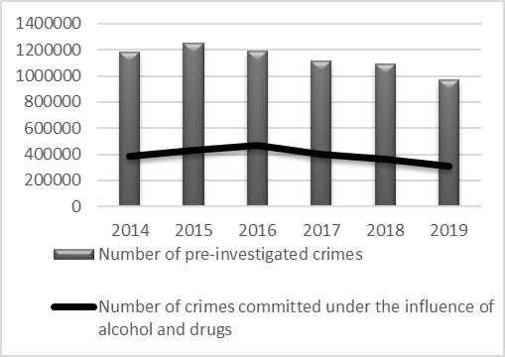

**Fig. 1**. Number of solved crimes by year

Manifestations of intoxication are different when taking different types of psychoactive substances or alcohol, but there are also similarities. The most reliable signs of opiate intoxication are narrowing of the pupils (the pupils do not dilate in low light). Narcotic intoxication when taking sleeping pills and sedatives is similar to alcohol intoxication – the pupils are dilated, salivation is increased.

The reaction of the pupils to an irritant (light, sound, logistic, pain, etc.) is an unconditional reflex that cannot be controlled by the cortex of the brain, and therefore by the consciousness. Thus, the pupil of the human eye is the most convenient and accessible indicator for studying the functional state of the Central and peripheral nervous systems of the human body, including the function of the autonomic nervous system.

Pupillometry is a research method which uses registration of the pupil size and the dynamics of its change. An electronic telemetry device is currently most often used for such registration, which accurately captures the pupil reflex based on changing the intensity of light reflected from the surface of the eye [3].

As a method of objective reflection of the psychophysiological state pupillometry is used in many areas [4]:

* in professional selection for professions that require a significant amount of attention and a high reaction rate;
* when determining the current psychophysiological state of the specialist before the start of the shift (pre-shift monitoring);
* when diagnosing the pharmacological effects of certain medications, as well as objective detection of signs of intoxication, which may indicate the drugs or alcohol taking.

If laboratory conditions are met, pupillometry methods are fairly accurate. Since pupillometry is a non-invasive method (not related to interference with the body), has a relatively high throughput (the diagnostic time taking into account the preparation and diagnosis of about 2-3 minutes), the use of pupillometry for rapid diagnosis is a very promising way to determine the state of intoxication. There are also disadvantages – expensive equipment and low mobility [5].

Pupillography is the dynamic recording of the pupil's response to a light flash.

The list of informative parameters of pupillography described in the literature, includes the following parameters: primary diameter (DN), the latent period of contrac-tion (TLC), the amplitude of contraction (AC), time contraction (TC), the velocity of constriction (VC), the latent period of expansion (TLR), time extensions (TR), the expansion speed (VR), and total reaction time (T) (Fig. 2) [6].

This method allows to diagnose a pupillary reaction, however, for a state of severe intoxication, including narcotic the pupils will differ from the "normal" ones for this background brightness without a light pathogen [6].

Changing the pupil diameter can be caused by various reasons, including emotions, but the main reason is the background brightness changing. As the background brightness increases, the pupil diameter decreases. The dependence of the pupil diameter on the background brightness is expressed by the formula (1) [7].

*Dp = 5 – th(0.4lgL)* (1)

where Dp – diameter of the pupil, mm; L – background brightness, cd/m2.

Thus, the discrepancy between the diameter of the human pupil and this formula most likely characterizes any pathology, including suggesting the presence of signs of intoxication.

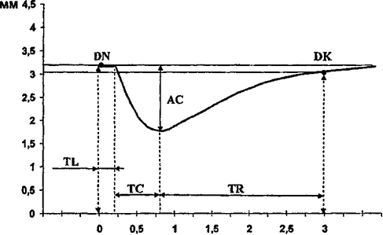

**Fig. 2**. Example of a pupillogram

3. Data preprocessing

According to the International Classification of Diseases of the 10th revision (ICD-10), acute intoxication caused by using alcohol or psychoactive substances is a special state that occurs due to the intake of alcohol or other psychoactive substance, leading to disorders of consciousness, cognitive functions, perception, emotions, behavior or other psychophysiological functions and reactions [1].

In 2019, the number of crimes committed while under the influence of alcohol was 297822. The number of crimes committed in narcotic intoxication is significantly fewer. In 2019, 9501 offences of this type were disclosed [2].

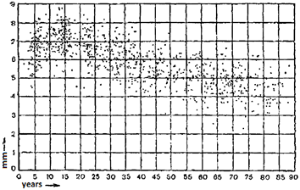

**Fig. 3**. Scatter plot of dependence of the pupil diameter from age

This graph clearly shows the spread of values within the same age and a pronounced pupil constriction with age. Based on this graph, we can conclude that due to differences in physiology of human of the same age, the pupil diameter may differ by 3-3. 5 mm.

Thus, when collecting and preparing input data consisting of the pupil diameter and the illumination value, it is optimal to allow an error ±1.7 mm for the first. Therefore, the graph of the pupil diameter plotted against the illumination of the surrounding background with an error will have the form as shown in Fig. 4.

A neural network (NN) is a set of neural elements that are connected to each other and to the external environment in a certain way using linkages determined by weight coefficients. Depending on the location and functionality, there are three types of neurons in the neural network:

1. input neurons (input layer neurons) that receive the input signal vector;
2. output neurons (output layer neurons) which output values represent NN outputs;
3. intermediate neurons (hidden layer neurons) that form the basis of neural networks.

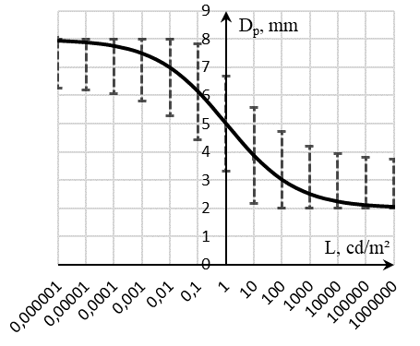

**Fig. 4**. Graph of the pupil diameter plotted against the illumination with an error

Based on the graph (Fig. 4), we make a training sample for the neural network, which have 2 inputs: the diameter of the human eye pupil in mm and the value of ambient light in Lux. The neural network output should give a response in the form of 1 or 0, indicating the "normal" functional state of the person or the presence of any deviations, respectively.

Since the neural network is not able to recognize units of measurement, the input data must be normalized before being submitted to the input, i.e. it must be converted into the form from 0 to 1. This is done by dividing each element by the maximum number from the input set. Since the neural network is expected to respond in the form of 0 or 1, the output signal does not need to be normalized.

In order to solve the problem of analyzing the parameters of the human eye pupil, we will use a neural network that has 2 input neurons, 3 hidden layer neurons, and 1 output neuron.

For building a neural network, the open-source NumPy library for the high-level Python programming language is ideal.

The NumPy library provides implementations of computational algorithms (in the form of functions and operators) that are optimized for working with multidimensional arrays. As a result, any algorithm implemented using this library and expressed as sequential operations on arrays (matrices) will work at the same speed as the code executed in MATLAB [9]

After training the neural network with a training sample, the testing showed that the developed neural network copes well enough with the classification of functional States based on input data, i.e. this neural network is quite suitable for performing the task of assessing the functional state of a person.

4. Software development

The client part of the application was written using Android Studio, an integrated development environment (IDE) for working with the Android platform, in the object-oriented Java programming language.

The server side of the application is written in the high-level general-purpose programming language Python.

Tasks that are performed on a smartphone:

1) Taking photos. When you click the makePhoto button, the makePhotoButton function is called, which passes control to the camera and waits for a response in the form of a captured photo. For shooting, you can choose the main or front camera. Keep in mind that when shooting with a front-facing camera, the photo quality may not be sufficient for further processing and successful completion of the task.

After receiving the result from the camera and checking for completion of the operation without an error, the makeRequest() method is called, which sends a request to the server.

2) Obtaining the luminance value of the environment. All modern mobile phones are equipped with a light sensor, which is mainly used to automatically adjust the brightness of the screen. This TYPE_LIGHT sensor measures the degree of illumination in Lux. To get data from sensors, the SensorManager is used. It allows you to access all available Android phone sensors.

3) Connecting to the server and sending data. When the makeRequest() function is called, an HTTP request is created using the okhhtp3 library, in which body the captured photo and the value obtained from the light sensor are entered. In the application, you can enter the IP address and port of the server yourself, or use the default server.

4) Receiving a response from the server and displaying the result on the screen. Upon successful connection to the server and request sending, a response is expected. The response is a text string in the form of "Normal FS" or "Deviation". This data is displayed on the screen. Then there is another opportunity to shoot a photo.

The server receives the data and recognizes the iris and pupil in the photo. To recognize the eye, iris, and pupil, you need a library of computer vision algorithms, image processing, and general-purpose numerical algorithms with open source OpenCV (Open Source Computer Vision Library).

Structurally the code of the server part of the application consists of three modules:

* server.py;
* detector.py;
* neuralNetwork.py – developed neural network.

Module server.py is responsible for server deploying, receiving the data from the client, controlling the transfer of information between modules, and sending a response to the client. To communicate with the client application, you need to bring this server up on one of the available ports.

The main method in the server.py class is an iris_detect function borrowed from the class detector.py. It is executed when receiving a request from the client and responsible for transmitting data to the detector class, receiving it’s results, transmitting data to the neural network, and sending a response to the client. In this function, the value of the light level from the client request is written to the local lux variable. Then the resulting image is added to the file variable, which is assigned to the content variable as a sequence of bytes. Next, a two-dimensional array of the NumPy type is created, which will store a map of image points with their RGB values.

Next, the source image is saved to the img variable in the form OpenCV library or rather its module for working with cv2 images can work with.

The resulting image with the eyes, iris, and pupils high-lighted is saved in the format .jpg with name consisting of the date and time at which the processing was performed. If necessary, this file can serve as proof or, if there is a recognition error, help you solve the problem.

After recording, if the eye elements are successfully recognized in the image and the pupil diameter is calculat-ed, the response to the client will be the value returned by the neural network (processing (result, lux), where lux is the illumination value). Otherwise, the mobile app will receive the message "Pupils not recognized!".

Module detector.py is responsible for performing one of the most important tasks of the application - calculating the diameter of a person's pupil. The OpenCV-Python library's cv2 module is also imported here.

All operations for detecting elements in an image are performed after the image is grayed out. This is achieved by running the image_in_gray = cv2 com-mand.cvtColor(image, v2.COLOR_RGB2GRAY), where image is the original image.

Achieving this goal involves several stages, each of which can be considered as a separate subtask. Calculating a person's pupil diameter from a photo in this project involves performing several steps:

1) Identifying the scope. In this case scope refers to the human eyes, because this is where the irises and pupils will be detected. The algorithm for finding eyes in an image is present in the OpenCV library. It is implemented in the eye_cascade method.detectMultiScale(), where eye_cascade = cv2.Cas-cadeClassifier('./haar/haarcascade_eye.xml').

2) Detection of the iris. Iris detection reminds the detection a circle in which the iris can be inserted. You can search for circles in an image using various methods. The most popular method of computer vision among researchers is the Hough transform [10]. This algorithm is implemented in the cv2 method.HoughCircles () of the OpenCV-Python library.

3) Detection of the pupil. Pupil detection is similar to iris detection but more challenging. The reason is that the boundaries of the pupil are much less distinguishable, in particular for people with dark brown eyes, the pupil almost merges with the background of the iris. Even if it is a light shade the iris is always clearly distinguishable against the background of the protein, in relation to the pupil this is not observed. The iris pattern has a complex pattern that creates a basis for false recognitions. The pupil boundary is not a circle, but a closed curve with many bends.

To detect pupils in the found irises, the brightness of the entire image need to be increased because the pupil is the darkest part of the image. Increasing the brightness leads to situation when the iris is lit up and become indistinguishable from the protein. The pupil also changes color, remaining clearly visible. The result of using this method is obtaining an image with an indistinguishable iris and a clearly visible pupil border. Next, we use the already known function for finding circles. The pupil is determined by selecting the circle with the center that is closest to the center of the iris.

4) Measuring the diameter of the found pupil.

There are two ways to calculate the pupil diameter from its image:

a) Calculate it geometrically if the distance to the pupil S and the angle of view A of shooting tool are known.

Let's say Y is the width of the image in pixels, d is the diameter of the pupil in pixels, *Yp* is the real width of the image in mm and *Dp* is the real diameter of the pupil in mm:

*tg(A/2)=0.5Y/S (2)*

*Yp=tg(A/2)×2S (3)*

*Dp=(d/Y)×Yp (4)*

b) Compare the diameter of the pupil on the screen with the size of the object, which is known in advance. This can be a special label, ruler, etc. for Example, A – the size of the object being studied on the screen, B – the size of a known object on the screen (both in pixels), *Bp* – the real size of the object in mm. Then the real size of the object *Ap* is calculated using the formula:

*Ap=(A/B)×Bp (5)*

For the purposes mentioned above, the second method is more preferable, since in order to know exactly the distance to a person's pupil, it is necessary that the person put his head on a special stand or put on special glasses. In this case, the iris acts as an object whose size is known in advance. Since the outer border of the iris remains unchanged, does not react to light, and is approximately the same while speaking of most adults, the diameter of the pupil can be determined by comparing the size of the previously obtained circles. The pupil diameter is smaller than the iris diameter as much as the diameter of the resulting pupil circumference is smaller than the diameter of the resulting iris circumference.

After determining the ratio of the diameter of the smaller circle to the diameter of the larger one, we multiply the resulting number by 12 (the diameter of the iris of most adults in millimeters), and get the diameter of the pupil. Then this value and the image with the selected objects are returned to the server.py.

Next, the calculated value of the pupil diameter and the resulting ambient light value are fed to the input of the neural network module. The resulting neural network response is sent back to the client for display on the smartphone screen.

In general, the algorithm of the application can be described by the block diagram in Fig. 5.

5. The application testing

The software testing is carried out with different people at different levels of ambient light. To test all possible cases, lines of code to output data to the Python console were added the server side and the entered numbers were read from the console. This makes it possible to change the values of variables in real time.

Samsung S8 Plus on Android 8.0 (API level 26 – Oreo) was used for testing. Camera resolution is 12 MP.

To assess the quality of the application, along with taking another photo, the pupil diameter was measured manually by using a transparent ruler. The results of the tests are shown in table 1. Values modified during program execution are shown in italics, and the original values are shown in parentheses.

6. Conclusion and future work

Based on the results of the work, a client-server application was implemented to improve the efficiency of determining person’s functional. The developed neural network almost accurately copes with the task. The server can simultaneously process requests from a huge number of clients, which allows clients to be located in different parts of the world.

During testing the developed application accurately determined the functional state of a person based on neural network analysis, which indicates the possibility of its effective application in order to ensure public safety.

In the near future, it is planned to finalize the application by adding the ability to determine the functional state of a person via frame-by-frame analysis of video sequence depicting a pupil's reaction to the brief light exposure.

**Table 1.** Research results.

|  |  |  |  |  |  |
| --- | --- | --- | --- | --- | --- |
| № | The degree of illumination | Diameter calculated by the application | Result of manual measurement | The result of the execution of the application | Expected result (normal FS or deviation) |
| 1 | 0,18 | 5,627 | 6 | Normal | Normal |
| 2 | 0,0064 | 6,582 | 7 | Normal | Normal |
| 3 | 1 (25641) | 2,34 | 2 | Deviation | Deviation |
| 4 | 13486 | 3,5 | 4 | Normal | Normal |
| 5 | 15267 | 3,5 | 4 | Normal | Normal |
| 6 | 0,0815 | 6,24 | 6 | Normal | Normal |
| 7 | 1784 | 5,34(2,18) | 2 | Deviation | Deviation |
| 8 | 235(0,01) | 6,516 | 6 | Deviation | Deviation |
| 9 | 0,157 | 6,2 | 6 | Normal | Normal |
| 10 | 58 | 3,618 | 4 | Normal | Normal |

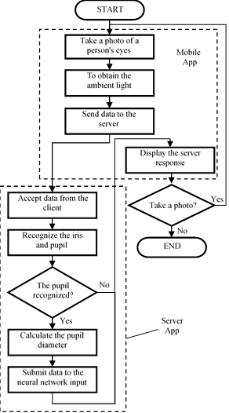

**Fig. 5**. Block diagram of the application

References

1. The international classification of diseases of the 10th revision, ICD-10, was approved at the 43rd session of the world health Assembly in may 1990. https://icd.who.int/browse10/Content/statichtml/ICD10Volume2_en_2010.pdf. Accessed 23 Jul 2020

2. The portal of legal statistics. Prosecutor General's office of the Russian Federation. Available at: http://crimestat.ru. Accessed 19 Nov 2019

3. Janisse M.P (1977) Pupillometry. The psychology of the pupillary response. Washington: Hemisphere Publ. Corp.

4. Nakakoga S, Higashi H, Muramatsu J, Nakauchi S, Minami T (2020) Asymmetrical characteristics of emotional responses to pictures and sounds: Evidence from pupillometry. PLoS ONE 15(4). doi:10.1371/journal.pone.0230775

5. Hyun Jin Song, Heejeong Son, Hyun-Ju Seo, Heeyoung Lee, Sun Mi Choi, Sanghun Lee, Effect of self-administered foot reflexology for symptom management in healthy persons: A systematic review and meta-analysis, Complementary Therapies in Medicine, Volume 23, Issue 1, 2015, Pages 79-89. doi:10.1016/j.ctim.2014.11.005

6. Murillo R, Crucilla C, Schmittner J, Hotchkiss E, Pickworth WB. Pupillometry in the detection of concomitant drug use in opioid-maintained patients. Methods Find Exp Clin Pharmacol. 2004;26(4):271-275

7. Martyn, C N, and D J Ewing. “Pupil cycle time: a simple way of measuring an autonomic reflex.” Journal of neurology, neurosurgery, and psychiatry vol. 49,7 (1986): 771-4. doi:10.1136/jnnp.49.7.771

8. Miller, S D, and H S Thompson. “Edge-light pupil cycle time.” The British journal of ophthalmology vol. 62,7 (1978): 495-500. doi:10.1136/bjo.62.7.495

9. SciPy PerformancePython. https://scipy.org/PerformancePython. Accessed 29 Nov 2019

10. BARBOSA, W.O., & VIEIRA, A.W.. (2019). On the Improvement of Multiple Circles Detection from Images using Hough Transform. TEMA (São Carlos), 20(2), 331-342. Epub September 16, 2019. doi:10.5540/tema.2019.020.02.0331